Mission To Mars

News. Facts. Hemisphere images.

[Get Data!](http://127.0.0.1:5000/scrape)

Latest news:

**NASA Invites Students to Name Mars 2020 Rover**

Through Nov. 1, K-12 students in the U.S. are encouraged to enter an essay contest to name NASA's next Mars rover.

Featured image:

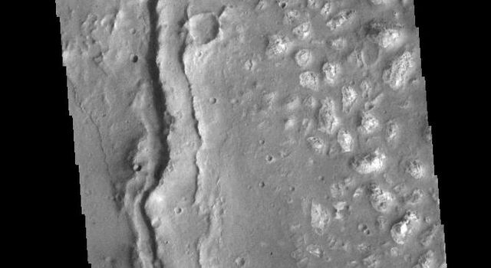

Mars Fact Table:

|  | **0** | **1** |
| --- | --- | --- |
| **0** | Equatorial Diameter: | 6,792 km |
| **1** | Polar Diameter: | 6,752 km |
| **2** | Mass: | 6.39 × 10^23 kg (0.11 Earths) |
| **3** | Moons: | 2 ( Phobos & Deimos ) |
| **4** | Orbit Distance: | 227,943,824 km (1.38 AU) |
| **5** | Orbit Period: | 687 days (1.9 years) |
| **6** | Surface Temperature: | -87 to -5 °C |
| **7** | First Record: | 2nd millennium BC |
| **8** | Recorded By: | Egyptian astronomers |

Mars Hemisphere Images:

Cerberus Hemisphere Enhanced

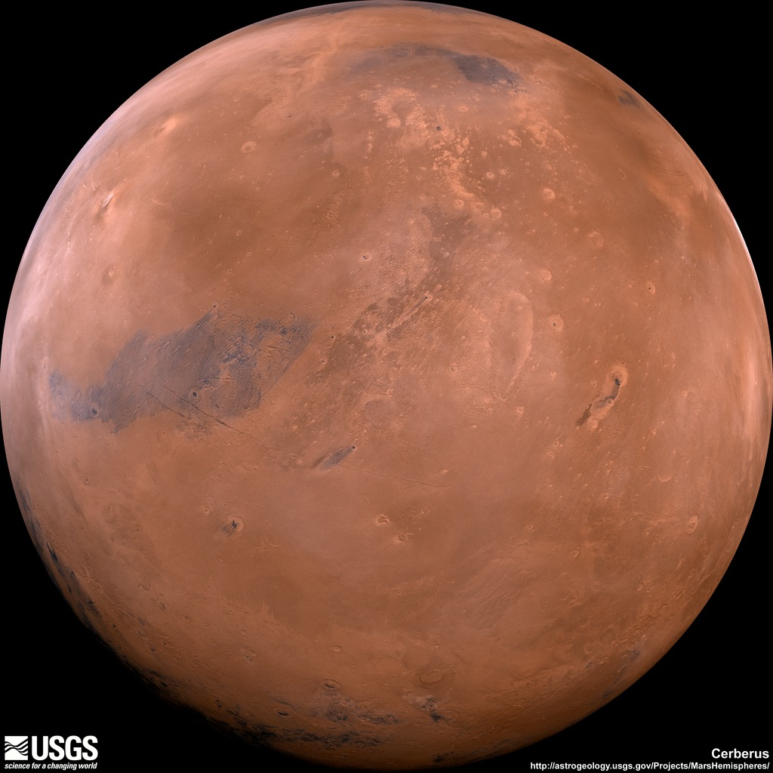

Schiaparelli Hemisphere Enhanced

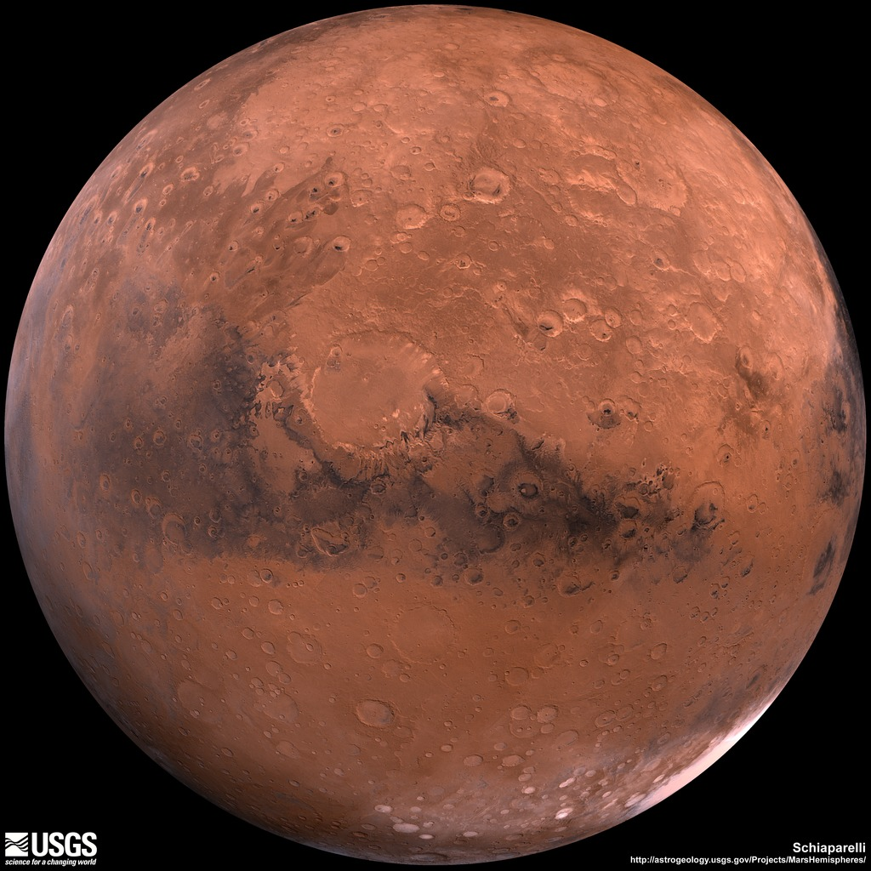

Syrtis Major Hemisphere Enhanced

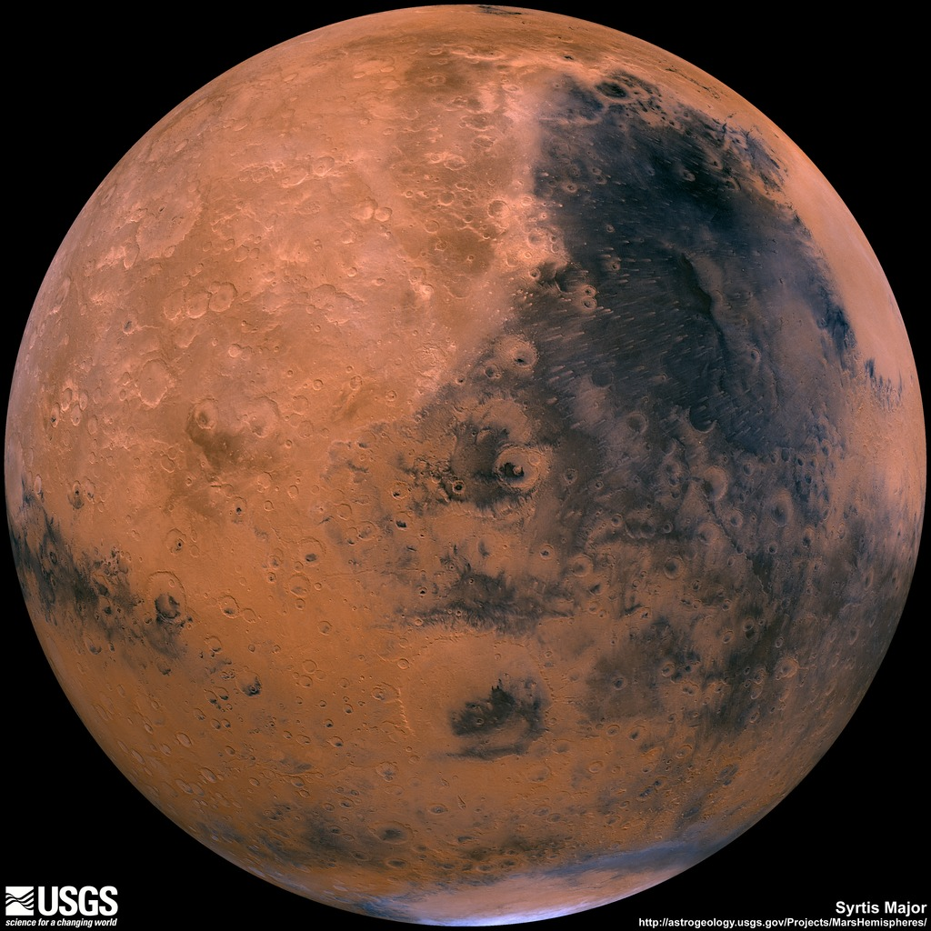

Valles Marineris Hemisphere Enhanced

